Explore Azure Database for MySQL

In this exercise you’ll provision an Azure Database for MySQL resource in your Azure subscription.

This lab will take approximately **5** minutes to complete.

Before you start

You’ll need an [Azure subscription](https://azure.microsoft.com/free) in which you have administrative-level access.

Provision an Azure Database for MySQL resource

In this exercise, you’ll provision an Azure Database for MySQL resource.

1. In the Azure portal, select **＋ Create a resource** from the upper left-hand corner and search for *Azure Database for MySQL*. Then in the resulting **Azure Database for MySQL** page, select **Create**.
2. Review the Azure Database for MySQL options that are available. Then for **Resource type**, select **Flexible Server** and select **Create**.

[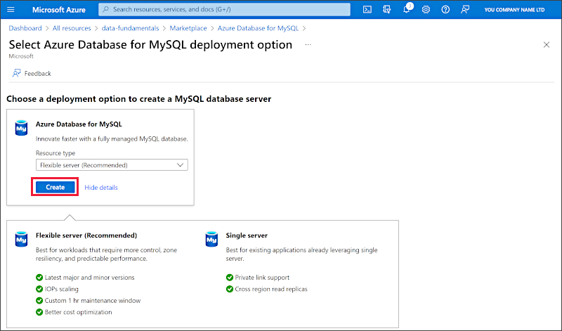](https://microsoftlearning.github.io/DP-900T00A-Azure-Data-Fundamentals/Instructions/Labs/images/mysql-options.png)

1. Enter the following values on the **Create SQL Database** page:
   * **Subscription**: Select your Azure subscription.
   * **Resource group**: Create a new resource group with a name of your choice.
   * **Server name**: Enter a unique name.
   * **Region**: Any available location near you.
   * **MySQL Version**: Leave unchanged.
   * **Workload type**: For development or hobby projects.
   * **Compute + storage**: Leave unchanged.
   * **Availability zone**: Leave unchanged.
   * **Enable high availability**: Leave unchanged.
   * **Admin username**: Your name
   * **Password** and **Confirm password**: A suitably complex password
2. Select **Next: Networking**.
3. Under **Firewall rules**, select **＋ Add current client IP address**.
4. Select **Review + Create**, and then select **Create** to create your Azure MySQL database.
5. Wait for deployment to complete. Then go to the resource that was deployed, which should look like this:

[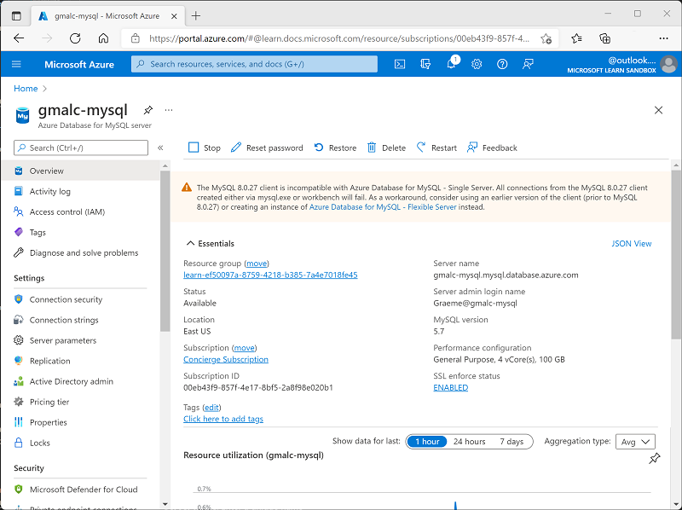](https://microsoftlearning.github.io/DP-900T00A-Azure-Data-Fundamentals/Instructions/Labs/images/mysql-portal.png)

1. Review the options for managing your Azure Database for MySQL resource.

**Tip**: If you’ve finished exploring Azure Database for MySQL, you can delete the resource group that you created in this exercise.